City of Pasco Fire Department

2016
Fire Department Performance Measures Report

2016 Fire Department Performance Measures
Table of Contents

Contents
Pasco Fire Department Mission Statement 1
Fire Department Organizational Overview 2
Pasco Fire Department Organizational Chart 3
Staffing Levels and Distribution 4
2016 Response Statistics 5
Temporal Response Statistics – 2016 6
Call Processing 7
Turnout Time 8
Fire Suppression Travel Time for 1st Arriving Engine 9
Travel time for the deployment of a full first alarm assignment at a fire suppression incident. 10
Emergency Medical Services Travel Time 11
Basic Life Support 11
Emergency Medical Services Travel Time 12
Advanced Life Support 12
Hazardous Materials Travel Time 13
Technical Rescue Travel Time 14
Aircraft Rescue and Firefighting Travel Time 15
Wildland Firefighting Travel Time 16
2016 Results Analysis 17
Plan of Action 18
Attachment A 19
Attachment B 20

Pasco Fire Department Mission Statement
“Honorably Protect and Serve our Community”

Pasco Fire Department Vision Statement
- Maintain a highly qualified workforce grounded in humility, integrity, and respect for all cultures
- Promote progressive growth and expansion to meet the changing needs of the community
- Conduct ourselves professionally in our community at all times
- Promote a healthy and safe work environment
- Be the leading resource for community safety, education, and information
- Work collaboratively with labor and management to meet the community’s expectations
- Integrate the department into the community activities and events

Pasco Fire Department Values
- Promote morale, pride and accountability from the top down
- Maintain collaborative relationships with city departments and neighboring agencies
- Honor tradition and provide training and education by highly experienced personnel
- Remain progressive with innovation and technology through education and training
- Engage in active sharing of your knowledge and experience
- Earn respect daily

Fire Department Organizational Overview

The Pasco Fire Department (PFD) was established by council action on July 16, 1908 after a series of fires destroyed portions of the town. The current service area incorporates approximately 37 square miles with an additional seven square miles in the urban growth boundary. The department is led by the fire chief who is an at will position that is appointed through a competitive process by the city manager.

The Pasco Fire Department is an all-hazards career response force that provides Fire (urban structural, wildland and vehicle), Advanced Life Support Emergency Medical Services (EMS), Hazardous Materials, Technical Rescue (high and low angle rope, confined space, trench, swift-water, structural collapse and vehicle/machinery), and Aircraft Rescue and Fire Fighting services to the community. The department responds to an average of 5100 calls for service per year (2015-2016).

It is important to note that most uniformed members of the department are cross qualified in other disciplines such as incident command, technical rescue, aircraft rescue and firefighting, hazardous materials, public education, fire investigation and hostile environment response.

PFD has earned a Public Protection Class 5 from the Washington Surveying & Rating Bureau (WSRB) in 2016. The rating is the benchmark for many insurance companies in determining their insurance premiums for privately insured properties. The higher the rating, the greater likelihood of insurance premium increases. The WSRB rates four major categories: Fire Department (40% of total score), Water Supply (35% of total score), Fire Safety Control (16% of total score) and Emergency Communications (9% of total score). Each major category contains several subcategories. The total points issued in these areas is combined to provide a rating of a scale of 1 to 10, in which 10 is equal to being without fire protection and 1 representing the best fire protection available.

The fire department staffs three fire stations on a 24 hr. /7 day per week basis. The city is divided into three primary station response areas. Each response area is further sub-divided into fire management zones.

Pasco Fire Department Organizational Chart

The Pasco Fire Department operates under an established chain-of-command which has been determined by the City Council, who represent the public.

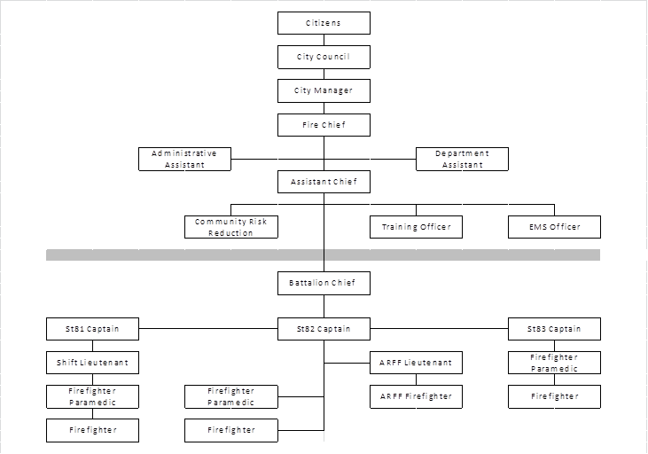

Staffing Levels and Distribution

In 2016, The City of Pasco Fire Department employed 60.75 uniformed career staff (6 of which are funded by contract with the Port of Pasco to provide Aircraft Rescue and Firefighting services to the Tri-Cities Airport) and 2.25 civilians. The department’s operations branch supported 57 of those uniformed members divided into 3 equal shifts of 19 members. The operations branch was supported by 4 uniformed members and 2.25 civilian personnel.

Maximum operational staffing was 19 and minimum operational staffing was 15 personnel.

The staffing distribution is indicated in the table below:
Station 81  310 N. Oregon Ave. | 1 Command vehicle  1 Type 1 Engine  1 Type 2 ALS Ambulance  1 Type 6 Engine  1 Type 4 Rescue Boat | 1 Battalion Chief  1 Captain & 1 Firefighter  1 EMT & 1 Paramedic  Unstaffed  Unstaffed | Minimum Staffing  5  Maximum Staffing  7
Station 82  3502 Varney Lane | 1 Type 1 Ladder  1 Type 2 ALS Ambulance  2 Type 1 ARFF  1 Type 2 Tender  1 Type 4 Light Rescue | 1 Captain & 1 Firefighter  1 EMT & 1 Paramedic  1 Lieutenant & 1 Firefighter  Unstaffed  Unstaffed | Minimum Staffing  6  Maximum Staffing  7
Station 83  3203 Rd. 68 | 1 Type 1 Engine  1 Type 2 ALS Ambulance  1 Type 6 Engine | 1 Captain & 1 Firefighter  1 EMT & 1 Paramedic  Unstaffed | Minimum Staffing  4  Maximum Staffing  5
Station 84  1208 Rd. 48 |  | Unstaffed

The Administrative Staff which includes the Chief, Assistant Chief, Training Officer, EMS Officer and secretarial staff are located at 1011 E. Ainsworth Ave. at the Fire Department Headquarters building.

2016 Response Statistics
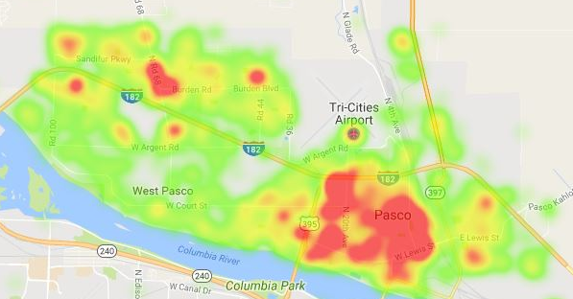
The heat map above indicates the 2016 call volume concentration within the City of Pasco. The orange shading represents the areas with the highest density call volumes.
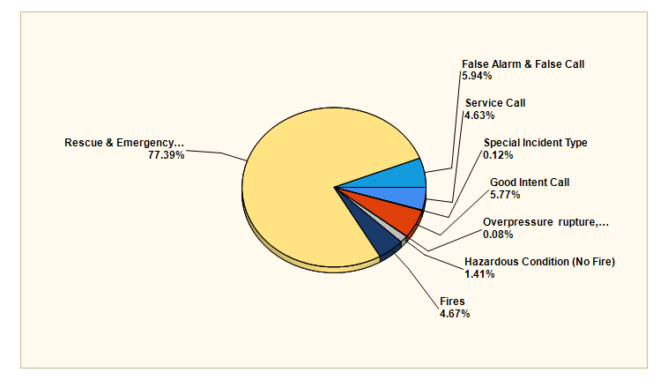

MAJOR INCIDENT TYPE | # INCIDENTS | % of TOTAL
Fires | 239 | 4.67%
Overpressure rupture, explosion, overheat - no fire | 4 | 0.08%
Rescue & Emergency Medical Service | 3960 | 77.39%
Hazardous Condition (No Fire) | 72 | 1.41%
Service Call | 237 | 4.63%
Good Intent Call | 295 | 5.77%
False Alarm & False Call | 304 | 5.94%
Special Incident Type | 6 | 0.12%
TOTAL | 5117 | 100.00%

The chart and tables above indicate the types and numbers of events that the Pasco Fire Department responded to in 2016. During 2016, 42.95% of all calls occurred while units were already engaged on another emergency.

Temporal Response Statistics – 2016

The charts below reflect the temporal call statistics experienced during 2016. Call volume by month tended to be higher during the summer months and during the holiday season, and hour of day tended to reflect the activity levels of the population. The call volume by weekday indicates very minimal change in activity from day to day.

Call Processing

Definition: Call processing is a measurement of the time from when the 911 call is answered at the Public Safety Answering Point (PSAP) until appropriate units are notified to respond. This performance standard is not a Washington State required performance measurement but is included here to more clearly define the total time involved in a response. The National Fire Protection Association (NFPA) standard for call processing is 60 seconds, 90% of the time.

Actual Dispatch Center Performance for 2016
The Franklin County Communications Center met the 60 second performance 68.7% of the time. 90% of the dispatches were processed in 1:34 seconds or less.

Turnout Time

Definition: The time after dispatch of the incident to don safety equipment and start the vehicles response to the incident (wheels rolling).

Turnout Time Standard:
The Pasco Fire Department has adopted a turn out time standard of 2 minutes, which the department should meet 90 % of the time. All firefighting safety equipment must be donned before the vehicle can leave the station for a fire response.

Actual Department Performance for 2016
All calls including outgoing mutual aid
The Pasco Fire Department met the Turnout Performance Objective 87.4% of the time.
90% of the fire department incidents experienced a turn out time of 2:08 minutes or less on 10,438 apparatus responses for calls within the city.

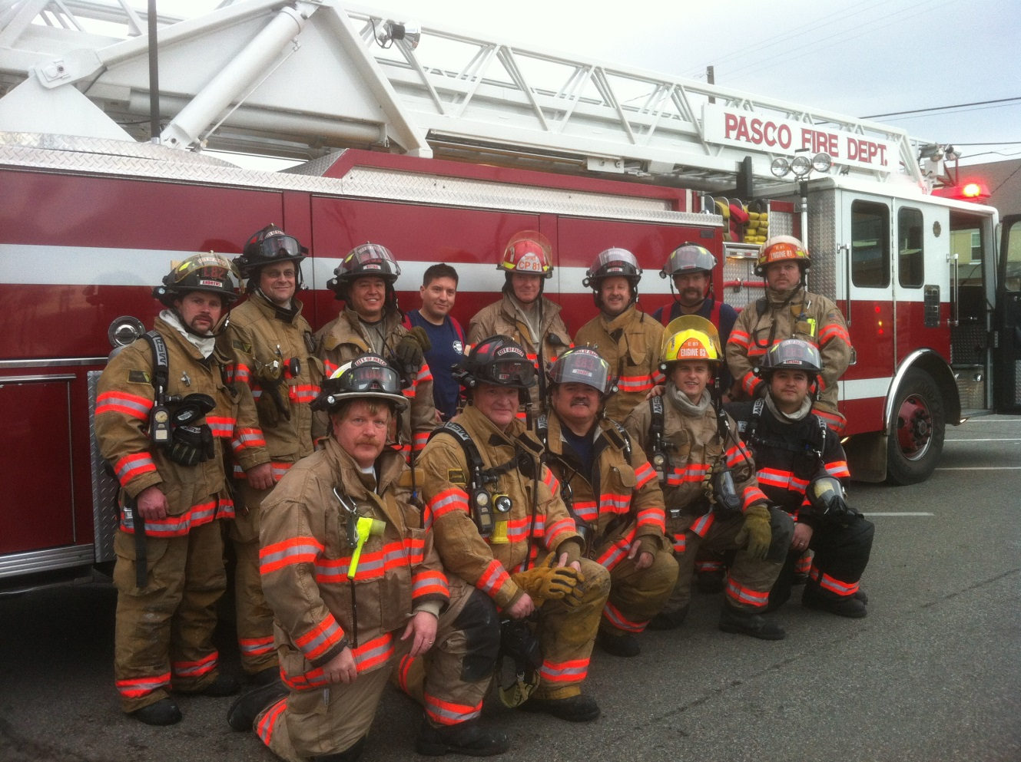

Fire Suppression Travel Time for 1st Arriving Engine

Definition: Travel time for the arrival of the first arriving engine company at a fire suppression incident. Response time starts after turnout when wheels are rolling and ends upon arrival at the incident.

Response Time Standard:
The Pasco Fire Department has adopted a response/travel time standard of 6 minutes for the arrival of the first engine company to a fire suppression incident, which the department should meet 90 % of the time.

Actual Department Performance for 2016
The Pasco Fire Department met the Response/Travel Time Performance Objective 91.6% of the time.
90% of the fire department incidents experienced a 1st unit response time of 5:54 minutes or less.
NFIRS Codes 100 through199, aid types, N, 1, 2.

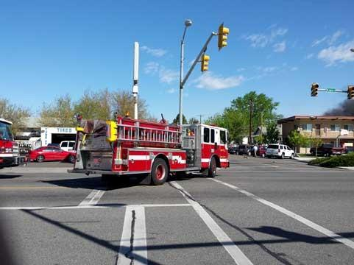

Travel time for the deployment of a full first alarm assignment at a fire suppression incident.

Definition: The total number of personnel and equipment the fire department has recognized as the minimum needed to combat a fire in a single family residence.

Travel Time Standard for Full 1st Alarm Response:
The Pasco Fire Department has adopted a response/travel time standard of 12 minutes for the arrival of the full complement of a 1st alarm assignment to a fire suppression incident, which the department should meet 90% of the time. Further, the Pasco Fire Department has adopted a 1st alarm response of 11 firefighters and or 2 engine companies (if applicable), 2 aid units, 1 ladder truck and 1 Command Officer (if applicable).

Actual Department Performance for 2016
The Pasco Fire Department met the standard of 11 or more personnel arriving on scene in 12 minutes or less 66.7% for residential structure fires when 11 or more personnel were initially dispatched. The 90th percentile for 11 or personnel more arriving was 16:17.

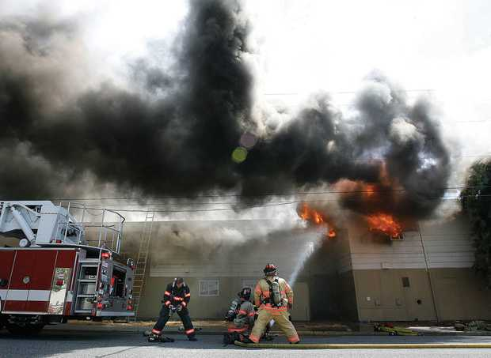

Emergency Medical Services Travel Time

Basic Life Support

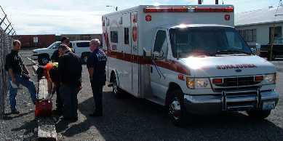

Definition: Travel time for the arrival of the first arriving unit with a first responder or higher level capability at an emergency medical incident.

Response Time Standard:
The Pasco Fire Department had adopted a response/travel time standard time of 6 minutes/seconds for the arrival of the first emergency medical unit with appropriately trained personnel on board to an emergency medical incident, which the department should meet 90% of the time.

Actual Department Performance for 2016
The Pasco Fire department met the Emergency Medical Services, Basic Life Support Performance Objective 90.8% of the time. 90% of the fire department incident experienced an Emergency Medical Services response time of 5:55 minutes or less.

NFIRS Incident Type codes 311, 321 through 324
Mutual Aid types 1,2 N

Emergency Medical Services Travel Time

Advanced Life Support

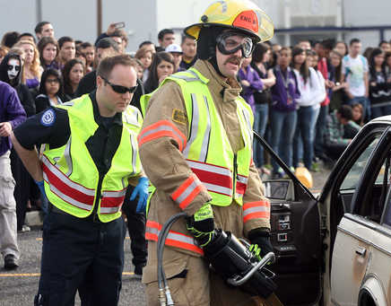

Definition: Travel time for the arrival of an advanced life support unit to an emergency medical incident, where this service is provided by the fire department.

Response Time Standard:
The Pasco Fire Department has adopted a response/travel time standard of 6 minutes for the arrival of an advanced life support (ALS) unit with appropriately trained personnel (paramedics) on board to an ALS emergency medical incident, which the department should meet 90% of the time.

Actual Department Performance for 2016
The Pasco Fire Department met the Emergency Medical Services Performance, Advanced Life Support Objective 90.8% of the time. 90% of the fire department incidents experienced an Emergency Medical Services response time of 5:53 minutes or less.

NFIRS Incident Type codes 311, 321 through 324
Mutual Aid types 1, 2, N

Hazardous Materials Travel Time

Definition: Travel time for the arrival of the first arriving apparatus with appropriately trained and equipped Hazardous Materials Level “A” Technicians on board at a hazardous materials incident, where this service is provided by the fire department.

Response Time Standard:
The Pasco Fire Department has adopted a response/travel time standard of 6 minutes for the arrival of the first unit with appropriately trained Hazardous Materials Technicians on board to a hazardous materials incident, which the department should meet 90 % of the time.

Actual Department Performance for 2016
The Pasco Fire Department met the Hazardous Material Response time Performance Objective 88.9% of the time. 90% of the fire department incidents experienced a Hazardous Materials response time of 6:27 minutes or less.

NFIRS Incident Type codes 410 through 413, 420 through 424 and 430 through 431.
Mutual Aid types 1, 2, N

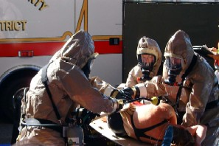

Technical Rescue Travel Time

Definition: Travel time for the arrival of the first arriving apparatus with appropriately trained and equipped Technical Rescue Technicians on board at the technical rescue incident, where this service is provided by the fire department.

Response Time Standard:
The Pasco Fire Department has adopted a response/travel time standard of 6 minutes for the arrival of the first unit with appropriately trained and equipped Personnel on board to a technical rescue incident, which the department should meet 90% of the time.

Actual Department Performance for 2016
The Pasco Fire Department met the Response/Travel Time Performance Objective 62.5% of the time.
90% of the fire department incidents experienced a 1st unit response time of 19:18 minutes or less.

NFIRS Incident Type codes 351, 354, 355, 356 and 360 through 365.
Mutual Aid types 1, 2, N

Aircraft Rescue and Firefighting Travel Time

Definition: Travel time for the arrival of the first arriving apparatus with appropriately trained and equipped Aircraft Rescue and Firefighting personnel on board at an aircraft incident, where this service is provided by the fire department.

Response Time Standard:
The Pasco Fire Department has adopted a response/travel time standard of 3 minutes for the arrival of the first unit with appropriately trained and equipped Aircraft Rescue and Firefighting personnel on board to an aircraft incident, which the department should meet 100% of the time. This standard is adopted to meet Federal Aviation Administration requirements, 14 CFR Parts 121 and 139.

Actual Department Performance for 2016
The Pasco Fire Department met the Aircraft Rescue and Firefighting performance Objective 75% of the time. 90% of the fire department incidents experienced an Aircraft Rescue and Firefighting response time of 3:33 minutes or less.

NFIRS Incident Type code 462
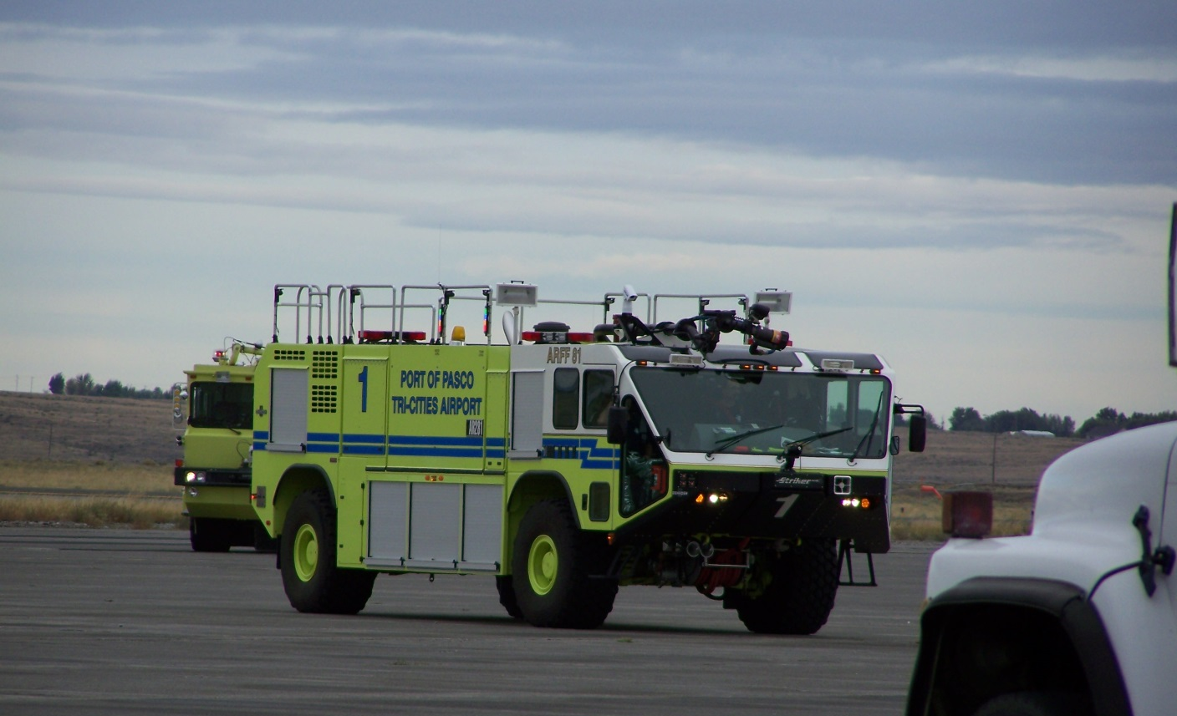

Wildland Firefighting Travel Time

Definition: Travel time for the arrival of the first arriving apparatus with appropriately trained and equipped Wild land Firefighting personnel on board at a wild fire incident, where this service is provided by the fire department.

Response Time Standard:
The Pasco Fire Department has adopted a response/ travel time standard of 6 minutes for the arrival of the first unit with appropriately trained and equipped Wildland Firefighting personnel on board to a wildland fire incident, which the department should meet 90% of the time.

Actual Department Performance for 2016
The Pasco Fire Department met the Wildland Firefighting Performance objective, 94.4% of the time.
90% of the fire department incidents experienced a Wildland Firefighting response time of 5:41 minutes or less.

NFIRS Incident Type codes 140, 141, 142 and 143
Mutual Aid types 1, 2, N

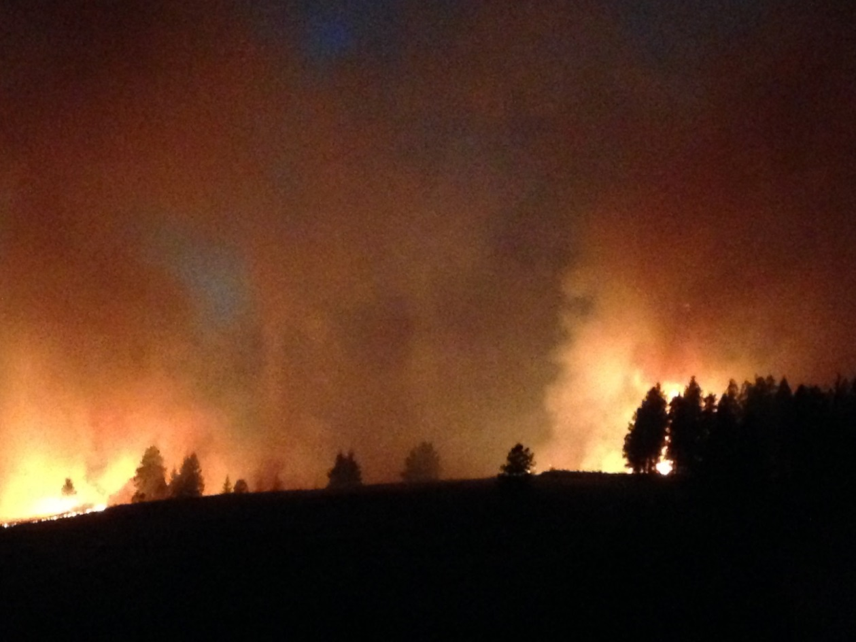

2016 Results Analysis

The City Council set the level of response times and level of service for the demographics of the City of Pasco. Total response times are a combination of three separate events (call processing, turnout time, and travel time). The fire department has direct control over only one of these factors ........turnout time. The Pasco Fire Department contracts dispatching services with the Franklin County Sheriff's office and as such does not have direct control over improvements to the call processing time. Travel times are affected by emergency vehicle speed, traffic congestion and response routing.

New construction has contributed to an increase in population (over 5% per year for the last three years) and has contributed to greater traffic congestion, especially on the Road 68 and 20th Ave. corridors. While traffic control improvements have been made on the Rd. 68 corridor, the increased traffic volume has kept response times substandard in the areas north of highway 182. Traffic improvements are planned for the 20th Avenue corridor (a main response route for stations 81 & 82) during FY-2017. It is expected that these improvements will negate the continuing volume growth of traffic for the next 5 - 10 years.

Temporal statistical analysis indicates that the department tends to be busier at those times when the population is more active, during the warmer months, weekends and daylight hours. Call volumes drop significantly during the early morning hours and colder months.

Travel time standards for those event types that did not require the activation of specialized resources, personnel or equipment (technical rescue, aircraft rescue and firefighting, and hazardous materials) are within the Council mandated time frames. Travel times for technical events are often skewed due to the nature of the incident. Factors that affect technical response times include the location of the incident (often outside of the normal response areas or zones) and the need for specialized resources. The travel time for the arrival of the full first alarm assignment is entirely dependent upon the availability of auto/mutual aid units.

The Incidents Heat Map (pg. 5) and the 2016 Fire Travel Times Map (Attachment A) indicate that the call volume concentration continues to grow to the north and west, and that those areas are not meeting the travel time standards. This can be attributed to increased population densities resulting in increased traffic congestion, especially during peak activity hours, and travel distances from the currently located station. As the population increases in the northwest sections of the City, we can expect a greater increase in travel times resulting in a declination of service provision.

Plan of Action

To meet the response time objectives for items above, the Pasco Fire Department will continue to evaluate its response data to determine if relocating resources, improving personnel reliability or other organizational changes may improve our ability to accomplish our response time standards. The Pasco Fire Department will continue to engage the public so they fully understand the level of service available based on the resources provided.

The data indicates that the fire department is unable to meet the response standards as mandated by the City Council in the northwest sections for the City. Growth in this area has out-paced the ability to provide timely services. The department will continue to monitor the growth in this area, and develop plans to mitigate the response times. These plans should include the provision for the development of a fourth fully-staffed station in the area.

Attachment A
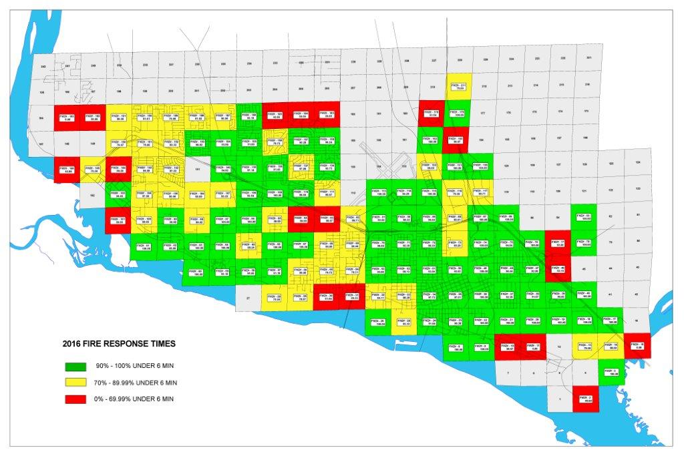

Attachment B
