**City of Pasco**

2017

**Community Risk Analysis**

**and**

**Risk Reduction Plan**

**Ben Shearer**

***Introduction***

The City of Pasco Fire Department, like many other fire departments across the nation are being challenged by budget crises, rising call volumes, personnel and equipment shortages, security issues and the overall public expectation to do more with less. Expectations placed on the fire service, including Emergency Medical Services (EMS), response to natural disasters, hazardous materials incidents, technical rescue and acts of terrorism, have steadily increased.

Traditionally, the focus of risk assessment was the identification of fire hazards and planning an appropriate response force to mitigate the emergency. Today, the risk assessment goes well beyond the fire problem and includes medical and other emergencies. Community risk assessment begins with the identification of the hazards present within the community and the understanding that the risk of fire, medical, or other emergencies cannot be held to zero. Community risk level is typically established through an overall profile of the community based on the unique mixtures of demographics, socioeconomic factors, occupancy risk, fire management zones, etc. and the overall level of services currently provided. The assessment of community hazards and associated risks are usually divided into three categories:

* Life
* Property
* Critical infrastructure

The objective of this document is to clearly define an overall risk profile for the City of Pasco and to identify a plan of action that will reduce the overall risk to the community to an acceptable level while factoring the maximum savings of life and property that is fiscally and morally responsible. In a nut shell, the goal is to create a safer community for anyone who lives in, works in, or travels through our community.

The Community Risk Analysis process is defined as a process to identify and prioritize local risks, followed by the integrated and strategic investment of resources to reduce their occurrence and impact.

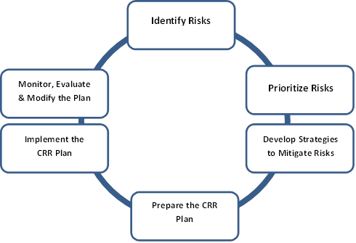

Community Risk Reduction (CRR) is not a new concept for the fire service. Fire departments have been actively involved in fire prevention for many years through public education, building Surveys and other activities. Although there is no specific blueprint for developing CRR plans, there are some common and essential steps.

Risk assessment is basically the identification of potential and likely risks within a particular community, and the process of prioritizing those risks. It is the critical initial step in emergency preparedness, which enables organizations to eventually mitigate (if possible), plan, prepare and deploy appropriate resources to attain a desired outcome.

***1A – Community Risk Assessment***

In order to properly quantify the risks and hazards of the City of Pasco, the overall risk profile of Franklin County must also be considered.

The City of Pasco is the county seat for Franklin County in southeastern Washington State. The County is generally characterized by a rising upland, with an elevation ranging from approximately 300 feet above sea level at its southern end to approximately 1000 feet in the northeast corner. The County is arid and averages less than ten inches of rainfall per year. The County is intersected by a major drainage (Esquatzel Coulee) as well as a number of lesser canyons and drainages. The underlying stratigraphy is characterized by numerous volcanic flows of basalt alternating with sands and other loessial materials which accumulated between various periods of historic volcanic activity.

The area receives an average of about 10 days of snowfall and 8 days of rainfall annually. The median monthly temperatures range from a low of 30.6 degrees Fahrenheit in January to a July high of 75.7 degrees Fahrenheit (although the region usually experiences periods of excessive heat >100 degrees Fahrenheit and extreme cold < 10 degrees Fahrenheit at times during the year). High wind velocities, with peak gusts as high as 70 mph or higher can be expected at any time during the year with associated frontal incursions.

Franklin County and the City of Pasco are accessible by several modes of transportation. Major highways, railroads, marine ports, and an airport are located within the City of Pasco boundaries. Interstate 182 runs through and connects the City with major markets to the east and west. US 395 is the primary north-south highway and runs through the eastern portion of the City and connects with Interstate 182. The Burlington Northern-Sante Fe Railroad operates a major switching yard within the City limits along the main east-west rail line that connects the Tri-Cities to Spokane and Portland, Ore. The Port of Pasco operates waterfront facilities that service barge traffic on the Columbia and Snake Rivers. The Port of Pasco Tri-Cities Airport (FAA Index B) is located on the northern boundary of the City.

The Pasco Airport (PSC) has three runways. Two runways are utilized by commercial aviation with the third runway used primarily by general aviation. PSC has experienced significant growth (34% - 2008 to 2011) in passenger enplanements. PSC is the fourth largest airport in the state and has 150 acres of commercial and industrial property on site.

The City of Pasco planning department reported that as of 2016, there were 22,282 single family residential units and 430 multi-family occupancies in the city and that 35% of the urban growth area is designated as Industrial.

Franklin County Emergency Management completed an extensive county-wide hazard assessment study in 2011. This study quantified and ranked the primary hazard concerns for the City of Pasco. The hazard concerns are listed in priority order below:

1. Severe Storm

2. Flood

3. Fire

**Severe Storm** – The effects upon the City of Pasco resulting from a severe storm such as a thunderstorm, tornado, windstorm, ice storm, or snowstorm are likely to be similar in nature. Downed trees and power lines, interruption of transportation routes, and damage to homes, businesses, and governmental buildings are all possible and will affect emergency response forces. The hazard assessment ranks severe storms as a high probability with associated moderate risk to lives and property.

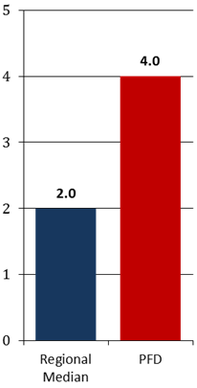**Flood** – The City of Pasco is located west of the confluence of the Snake and Columbia rivers and is part of the Yakima Delta. The threat of flooding in the City of Pasco is greatest in the months of December through February although flooding events may occur during other months of the year. Winter flood events have the potential to produce the highest peak flows when significant snowfall is present, followed by rapidly rising temperatures and/or heavy rains. The hazard assessment ranks flooding as a moderate probability and moderate risk to lives and property.

**Fire** – The Pasco Fire Department (PFD) experiences twice the regional median average of fires per 1,000 of population.

***Human and Technological Hazards***

***Hazardous Materials***

Hazardous materials incidents pose a significant threat to the City of Pasco. A hazardous materials incident can originate from a fixed facility or from any transportation medium. The manufacture, use, transportation, storage and disposal of hazardous material products and dangerous wastes poses a potential risk to the public health, safety and welfare, private and governmental properties, and the environment.

The U.S. Department of Transportation classifies a material as hazardous if it is corrosive, explosive, toxic, flammable, biologically irritating, radioactive, or packaged in a dangerous container.

These materials are regulated while in transit, and when stored on site by a variety of local, state, and federal guidelines. Federal regulations, such as Title III of the Superfund Amendments and Reauthorization Act, have made it easier for local governmental agencies to track the presence of hazardous materials in their jurisdictions.

Franklin County and the City of Pasco has suffered both transportation and fixed facility hazardous materials accidents. Most incidents have involved petroleum products, or agricultural products such as anhydrous ammonia. There has been a massive increase of the transportation of Baakan Crude Oil and Coal through Franklin County and the cities of Connell, Mesa and Pasco.

Major incidents include a 1996 release of 2000 gallons of anhydrous ammonia in downtown Pasco, forcing residential evacuation and sending over 100 people to be evaluated at the hospital, and a July 2011 train derailment involving methane gas on the Ainsworth artery.

Hazardous materials incidents occur suddenly and can cause damage to people and property without any warning. The impact of this type of emergency can last from a few minutes to weeks, months and even years before damage to the environment could be repaired.

Any incident in which hazardous materials are involved has the potential for escalation from a relatively minor incident into a full scale disaster. The hazardous properties of chemicals, motor fuels, radioactive substances and other potentially dangerous materials range from highly flammable to explosive to poisonous. These chemicals have the ability to contaminate the environment with quantities harmful to human, animal and plant life. The potential for loss of life, extensive property damage, environmental contamination, and economic loss always remains high when hazardous materials are involved.

The effects of a hazardous materials incident vary depending on such factors as the type and quantity of material(s) involved, the location, time of day, and weather conditions. In the case of airborne contaminants, wind speed and direction are extremely important for response procedures and capabilities. Mass evacuation or widespread shelter-in-place should be considered a high priority when dealing with airborne or potential airborne contamination.

***Pandemics***

A pandemic event will affect the City of Pasco personnel resources. Normally, influenza epidemics occur annually and usually peak between December and March in temperate regions in the Northern Hemisphere. In the United States, annual influenza epidemics are associated with an average of 36,000 deaths and more than 110,000 hospitalizations.

Based on previous pandemics, attack rates for influenza in a community during a pandemic are likely to be as high as 35%. Although influenza cases and deaths are likely to occur over a several month period throughout the U.S., within the community most of the impact is likely to occur within 4 to 8 weeks.

Health care demands are likely to increase substantially during a pandemic while simultaneously the City is likely to see a decrease in response personnel resources. These demands will likely lead to critical shortages and increased personnel costs.

In addition to the increased overall need for health care services, illness and death patterns during pandemic events may differ substantially from those seen during non-pandemic years when older adults and persons with compromised immune systems primarily are at risk for serious disease and death. During the three pandemics of the 20th century, a substantial portion of the total deaths occurred among persons younger than 65 years who would not be considered at high risk during non-pandemic years. Higher rates of work absenteeism are likely to occur as employees become ill or need to care for ill family members.

***Terrorism/Hostile Action***

The City of Pasco has several potential targets of interest for terrorist groups and/or are potential “soft targets” for hostile actions (active shooter). There are several large facilities that have extremely hazardous chemicals in their inventory, the county seat and city administration facilities are all located within close proximity of each other. Additionally, the City of Pasco is a transportation hub for rail, barge, vehicular and aviation travel. The Ice Harbor Dam is located 7 miles north of the city on the Snake River and there is a very large agricultural and food industry in the city that is susceptible to biological terrorism.

As of 2017, the Pasco School District funded 22 public schools within the city limits. The Columbia Basin College is also located within the city limits as well as two private schools.

***Summary of Human and Technological Risks***

|  |  |  |
| --- | --- | --- |
| Hazard | Probability | Risk |
| Hazardous Materials | Moderate | High |
| Pandemic | Low | Moderate |
| Terrorism/Hostile Action | Low | Moderate |

***Human and Technological Risks – Conclusion***

With the exception of a Pandemic, the human and technological risks are classified as relatively low frequency – moderate risk. These events will require specialized response capabilities such as Hazardous Materials Response Teams, Special Weapons and Tactics Teams, etc. The magnitude and duration of the event(s) can range the spectrum from acute (short-lived) to long term. The primary effects are likely to be economic and loss of life.

***Transportation Risks***

***Aviation***

The Tri-Cities Airport (FAA Index B), located in the north-central portion of the City of Pasco, is the largest airport in southeastern Washington and the fourth largest airport in the state of Washington with enplanements in excess of 300,000 per year (2014-2016). The airport is serviced by four commercial passenger airlines, commercial cargo services, charters, military and private aircraft.

The Pasco Fire Department responds to an average of 10 aviation incidents per year. The majority of these incidents are categorized as Alert 1 (the lowest risk category).

The major effects of an aircraft crash are dependent on the size of the aircraft, location and path of crash, and number of passengers and would include mass casualties/fatalities, fire/explosion, hazardous materials release and property damage.

***Railroad***

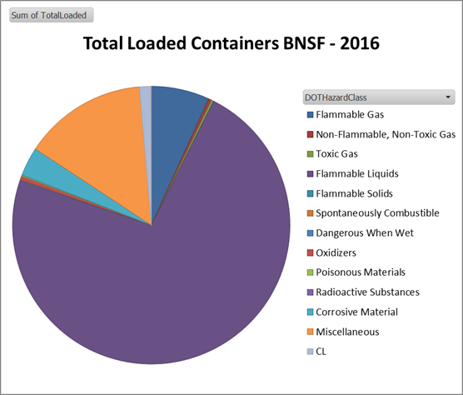The BNSF maintains the largest switching yard west of the Mississippi River in east Pasco. A 2016 Hazardous Materials Commodity Flow Through study conducted by BNSF indicated that the switch yard serviced 175,007 tank cars either partially or fully loaded with hazardous materials from all nine of the Department of Transportation hazard classifications.

The BNSF and Union Pacific maintain approximately 75 miles of railway adjacent to the Columbia and Snake Rivers. These railways transport five Bakken oil trains per day. Bakken oil is a light sweet crude oil, with volatility comparable to gasoline making it extremely flammable and hazardous.

***Highway***

The City of Pasco is bisected by Interstate I-182 (running east/west) and U.S. Route 395 (running north/south). Due to an increasing population, and the inter-modal methods of transportation that are supported in Pasco, vehicular traffic and accidents volumes continue to increase.

***Marine***

The Tesoro and Tidewater Pasco Terminals located in the Port of Pasco on the Snake River provide regional barge and rail terminal service and storage of petroleum, fertilizer, chemicals, and bio-fuels.

Tidewater Barge Lines is the largest inland marine transportation company west of the Mississippi River. Tidewater offers a comprehensive range of onshore and offshore cleaning and waste transportation services to the marine and industrial business markets. Tidewater transports refined petroleum products and bio-blends in 8 double hulled barges with a capacity of 264,000 barrels.

Tesoro Logistics LP is a full-service logistics company operating, through its subsidiaries in the western and mid-continent regions of the United States. Tesoro owns and operates over 4,000 miles of crude oil, refined products and natural gas pipelines, as well as 41 crude oil and refined products truck, marine and storage terminals and has over 26 million barrels of storage capacity.

The Pasco Tesoro Logistics site maintains 26 tanks with a potential capacity of over 500,000 barrels of primarily contain gasoline and other fuel products.

***Summary of Transportation Risks***

|  |  |  |
| --- | --- | --- |
| Hazard | Probability | Risk |
| Aviation | Low | Moderate |
| Railroad | High | Moderate |
| Highway | High | Moderate |
| Marine | Low | Low |

***Transportation Risk – Conclusion***

The City of Pasco serves as a transportation hub in southeastern Washington. Transportation hazards are unique in that the frequency and magnitude can be minimized. Using the threat matrix for transportation risks, the Pasco Fire Department must maintain a highly trained response force in heavy and light vehicle and machinery extrication, aircraft rescue and firefighting skills, hazardous materials response and water rescue.

***Community Overview***

The City of Pasco is a robust multi-cultural community with a rich history. Inhabitants have thrived along the banks of the Columbia and Snake Rivers for many years. Evidence of the earliest known inhabitants in the Western Hemisphere was found in northern Franklin County at the Marmes Rockshelter, near Lyons Ferry and Palouse Falls (approximately 35 miles northeast of Pasco). In 1805, the Lewis and Clark Expedition camped at the confluence of the Snake and Columbia Rivers. In the late 1800’s the Northern Pacific Railroad brought a rush of settlers to the Washington Territory and the railroad town of Pasco was born.

The City of Pasco was incorporated on September 3, 1891. Pasco is the second largest in population of the three cities that regionally comprise the Tri-Cities area in southeastern Washington State. The city currently encompasses approximately 37 square miles that includes over 13 river miles of water front, with an additional seven square miles designated as the urban growth boundary.

***Population***

The 2010 census reported a population of 59,781 with a density of 1960 inhabitants per square mile. There were 18,782 housing units with an average density of 615.8 per square mile. The 2016 postcensal estimate of total housing units provided by the Washington State Office of Financial Management is 22,282 at an average density of 655.4 per square mile. The 2016 population data of the city is 70,560 with a population density of 2075 per square mile. The population demographic is 55.4% Hispanic, 1.8% African American, .3% Native American, 2.2% Asian, 0.1% Pacific Islander, and 38.5% white alone. Hispanic or Latino of any race comprised 55.7% of the population.

* 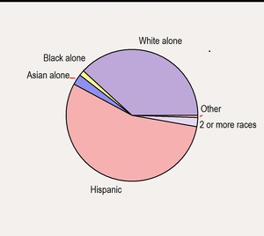Hispanic 55.4%
* White Alone 38.5%
* Asian Alone 2.2%
* Black Alone 1.8%
* Two or more races 1.7%
* American Indian 0.3%
* Other Race 0.7%
* Pacific Islander 0.1%

The 2010 census reported the median age in the city was 27.3 years. 35.5% of residents were under the age of 18; 10.6% were between the ages of 18 and 24; 29.9% were from 25 to 44: 17.2% were from 45 to 64; and 6.7% were 65 years or older.

Males represented 51.8% of the population and females represented 48.2% of the population.

***Economics***

Pasco has the lowest assessed value, lowest per capita income levels, lowest per capita sales tax revenue and the highest unemployment rates of the greater Tri-Cities region. The not seasonally adjusted unemployment rate for the City of Pasco is at 8.2% as of August 2013 (1% higher than the national average). The per capita income in Pasco is 37.1% less than the Washington average and 32.7% less than the National average. The median household income is 24.7% less than the Washington average and 14.7% less than the national average. The poverty level in Pasco is 111.3% greater than the Washington average and 89.4% greater than the National average. The median household income is $60,054 (approximately $4,000 below the Washington State average), and the per capita income is $21,804.

The City’s economy is directly based on agriculture and related food processing and transportation. The Pasco Processing Center (a 240-acre industrial park designed for the food processing industry) was constructed in 1995. Several large food processors have built plants that utilize this facility.

The Hanford Reservation, located in Benton County, encompasses approximately 560 sq. miles and contains various nuclear and nuclear-related projects. Today, the focus of the Hanford Reservation is on energy research, environmental remediation/waste management and related technology.

The economy of Pasco has been affected for the past several years by incidents that include; manufacturing sector slowdown, inflation increases and corporate bankruptcies, layoffs and relocations, terrorism and energy pricing.

***Employment***

Several key critical infrastructures and major transportation hubs are located within the city boundaries of Pasco. The Tri-Cities Airport, a containerized port facility which serves extensive containerized barge traffic, and the largest rail switching yards west of the Mississippi River for the BNSF railroad are all located within the city limits. The City of Pasco is also bisected by Interstate I-182 (running east/west) and U.S. Route 395 (running north/south). Pasco is home to all of the local governmental facilities for Franklin County. Facilities such as the courthouse, county jail, Franklin County Emergency Management and county dispatch center are all located within the city limits. Pasco also has over 22 primary and secondary schools and is home to the largest public two-year community college in southeastern Washington.

Primarily due to the agricultural region, Pasco is home to several food processing companies such as ConAgra Foods, Reser’s Fine Foods, Pasco Processing, and Twin City Foods. In recent years, the region has become a large player and provider in Washington State’s wine industry. Gordon Brothers Cellars, Fidelitas Winery, Kamiak Vineyards and Preston Premium Wines have a presence in and around the city of Pasco.

***City of Pasco Risk Analysis - Methodology***

The Pasco Fire Department must thoroughly understand their community and the risks within the community. There are various risk/consequence or risk/probability matrices available; but regardless of the labels on the axis, they usually fall into one of the quadrants in the following figure. Utilizing data including event types, frequency of events, and resource needs the following risk analysis can be completed.

As the risk is generally quantified into one of the four quadrants, a decision is made based upon the level of risk. It is important to recognize that it is improbable, impractical and unaffordable to completely eliminate risk to the community. Using a matrix assists fire department officials in determining the acceptable level of risk. The four quadrants in the figure below may be defined as follows:

* Low impact/Low probability – Risks in the bottom left corner are low level, with acceptable consequences if the incident occurs. These can often be considered an acceptable risk and require no further action.
* Low impact/High probability – Risks in the top left corner are moderate level – if the incident happens, the fire department can usually handle it with existing resources. However, effort should be given to reduce the likelihood that these incidents occur.
* High impact/low probability – Risks in the bottom right corner are high level if they do occur, but they are very unlikely to happen. Risks in this quadrant are prime candidates for training and contingency planning.

* High impact/High probability – Risks toward the top right corner are critical. These should be the highest priorities for the fire department and for the community. Aggressive action is required such as staffing for these risks, equipping for these risks, and engaging the community in risk reduction and preparedness.



***Risk Attributes and Vulnerability***

***Response Statistics***

The Master Plan study conducted by ESCI compared the Pasco Fire Department to similar sized fire agencies within the 13 western states using the NFPA benchmark data for 2015. The conclusion reached by ESCI is that the Pasco Fire Department is a “very busy” primarily suburban fire department. The chart below indicates the breakdown of major incident types for 2015.

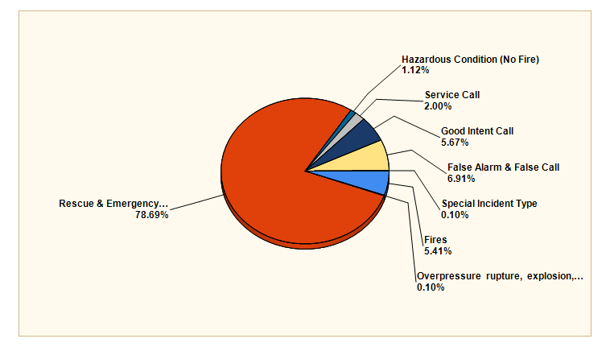

During the Master Planning process, Emergency Services Consulting International, determined that the Pasco Fire Department responded to 74.7 emergencies per 1,000 population in its service area, which is eight more responses per 1,000 population served (or 544 total responses more per year) than the regional median.

Historical analysis of call volume (2011-2015) as compared to population increase for the same time frame shows that the call volume increased an average of 16.9% per year while the population increase averaged 13.7% per year.

Overlapping calls are a significant issue for the Pasco Fire Department. Overlapping calls are defined as calls for service that occur while the primary response unit is already engaged in a previous emergency. These calls require secondary stations to cover the emergency resulting in longer response times and greater out of service times for units. The chart below shows the percent of overlapping calls for the 2011-2015 time frames.

|  |  |
| --- | --- |
| Overlapping Call Percentage per Year | |
| 2011 | 30.77% |
| 2012 | 30.34% |
| 2013 | 31.68% |
| 2014 | 32.35% |
| 2015 | 36.28% |

***Geographic Call Distribution***

ESCI plotted the incident locations and calculated the mathematical density of the 2013-2015 service demand for the PFD service area. The PFD service demand is concentrated in the central core area of the City of Pasco, between Station 81 and Highway 395. The commercial corridor along Rd. 68 as well as the residential neighborhoods north of I-182 experience higher incident demand density. As the northwest area of the city begins to “fill-in” it is expected that the demand for service in that area will trend towards the same levels as that of the central core of the city.

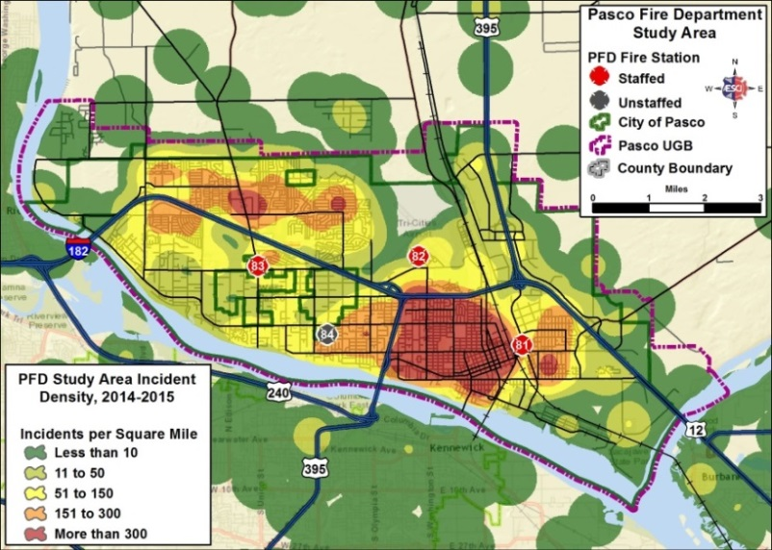

Fire incidents are the least frequent in the data set. However, incidents categorized as fires are equally distributed throughout the city in a similar pattern to the overall service demand. These fires have been located in the central section of the city between Station 81 and Hwy. 395 and south of I-182 to the southern urban growth boundary.

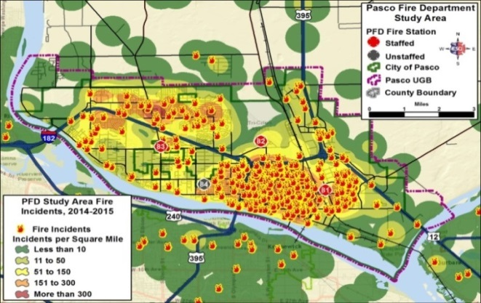

Statistically, fires represent one of the lowest probabilities of “traditional municipal” occurrence at 5.8% of total call volume (combining all event responses) and the highest resource usage, thus falling in the high risk category. Historically, the PFD has responded to an average of 1 structural fire every week, and a fire event every 35.04 hours. Fires represent an important factor in the risk assessment process because of the regularity of occurrence and the resource demands that are placed upon the department and the community in the form of increased need for social service interaction to the victim(s), additional support from the community government (building inspection for re-occupancy, police involvement for additional patrols, etc.) and a greater resource demand on the “micro-community” (family, workforce, etc.). Further, fire loss has a negative financial and public image impact to the community. Increasing fire loss reduces property values and results in diminishing General Fund revenues. The results of fire can also be detrimental to the future prospects of the community by affecting homeowner insurance ratings, property values, etc. The Pasco Fire Department has responded to an average of 53 structural fires per year since 2007.

Analysis of the fire problem within the City of Pasco indicates that the department responded to 535 structural fires from January 1, 2007 to May 1, 2017. A “deeper dive” into the statistics show that 33% of the recorded structural fires occurred in multi-family units.

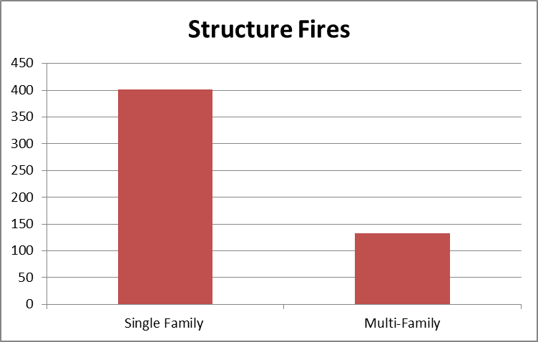

Of the structural fires noted, 35% are caused by cooking issues. Further analysis indicates that 45% of all cooking fires occur in multi-family structures.

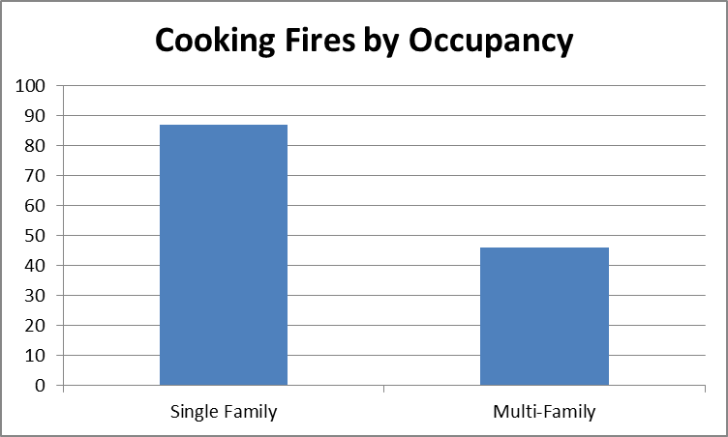

Temporal statistical data indicates that cooking fires tend to occur during the expected time frames based upon activity schedules of the populations. There was no significant statistical evidence that supported specific days of the week.

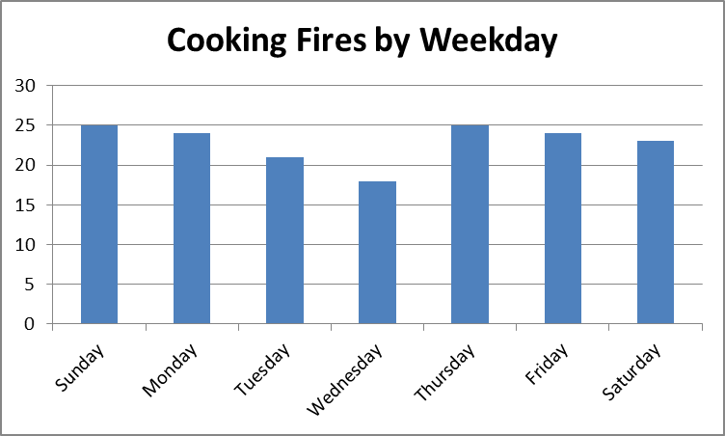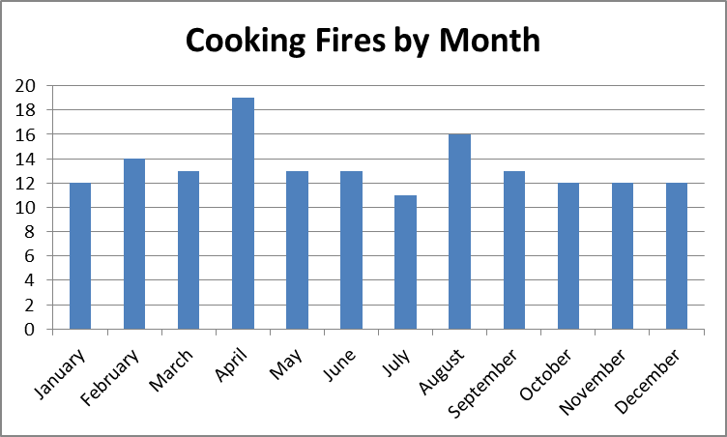

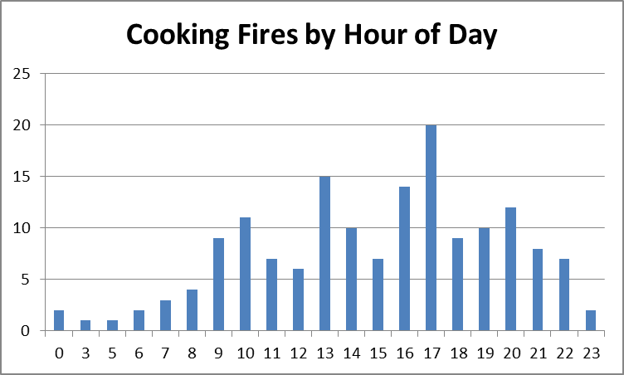

The cooking fires by hour of the day statistics support the anecdotal data that cooking fires usually occur at the times that residents are preparing meals and mirror the greater temporal response statistics.

***Fire Analysis***

Cooking Fires represent:

* **High impact/High probability** – These should be the highest priorities for the fire department and for the community. Aggressive action is required such as staffing for these risks, equipping for these risks, and engaging the community in risk reduction and preparedness.
* Multi-family residential occupancies represent 2% of the total occupancies within the City, but represent 45% of the cooking fires call frequency.

***Property Insurance information***

The chart below graphically represents data obtained from the office of financial management of Washington State. The chart below shows the insurance information for Pasco from 2015. Red indicates insufficient insurance coverage, blue indicates sufficient insurance coverage.

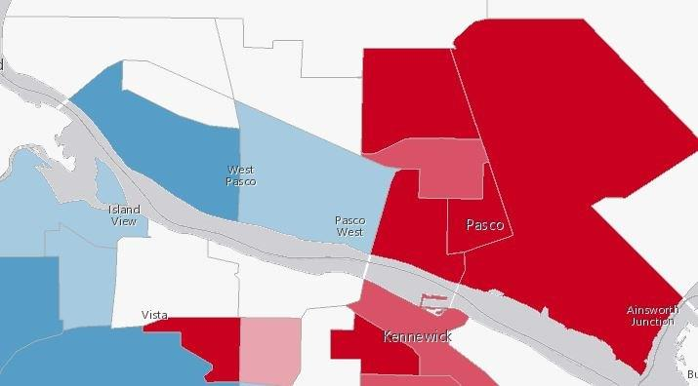

This is significant in that it shows that half of Pasco is underinsured against loss from fire. When a fire happens and the occupant is not insured against loss, they have to rely on community resources to keep them stable. If the building is not covered for the full loss, the building sits as an eyesore even longer. **“*In Pasco, most buildings sit vacant for at least 18 months before repairs are made and reinhabited”.*** *Troy Hendren, City of Pasco Fire Marshall.*

***Medical Services Statistical Analysis***

EMS calls also fall into the high risk category primarily due to the increased frequency and thus the increased exposure risk to crews and lower unit availability times. The department percentage of EMS calls as compared to total call volume average 78.7% per year. The Pasco Fire Department assisted 34830 patients during the sample time period. Individual EMS calls typically place a relatively low resource demand on the department as most EMS calls require the response of only one or two units. As the incident complexity increases (due to patient disposition and manpower requirements) more units are dispatched to assist in patient care. With increasing call volumes, the “over-lapping” of calls (as described above) negatively impacts unit availabilities. The risk of EMS calls is usually contained to the responding crews (injury and disease exposure) and can be minimized with proper training and equipment. The greater risk to the community is the resource drawdowns that occur with increased service demand and unit availability.

Female patients represent 48% of the population demographics and yet represent 52% of the total EMS response demographics. The average age by gender for EMS patients is indicated in the chart below.

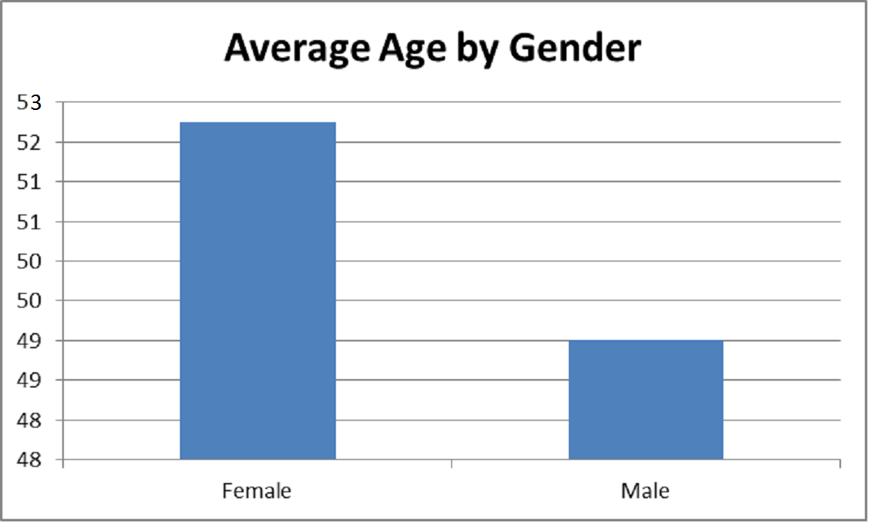

The median age of the population in the City of Pasco is 28.6 years, and the average age of patients served by the Pasco Fire Department is 50.75 years of age.

In November of 2015, The FCS Group completed an ambulance services rate study. The study considered response data from several years. The following table considers response data from 2014 only.

|  |  |  |
| --- | --- | --- |
| **Customer Class** | **Number of Calls** | **Percentage of Calls** |
| Single Family | 1362 | 39% |
| Multi-Family | 815 | 24% |
| Commercial/Business | 577 | 17% |
| Nursing Homes | 109 | 3% |
| Public | 541 | 16% |
| Miscellaneous | 61 | 2% |

Given the current and projected population growth rate of the City of Pasco, The FCS Group estimates that the demand for EMS services will increase at a rate of 2% per year for the foreseeable future. This would equate to an annual increase of 80-100 additional calls for service.

As noted in the fire problem analysis, EMS calls to multi-family residents represent a statistically significant issue in that the call volume per multi-family occupancy tends to be higher than that of the single family resident.

The table below indicates the primary patient complaints to the dispatch center.



Review of the EMS responder’s impression of patient chief complaints indicate that 70.51% of all transported patients fall into one of six categories; traumatic injury, abdominal pain/problem, chest pain/discomfort, altered level of consciousness, respiratory distress, and seizure disorder. The chart below indicates the responder’s impression.

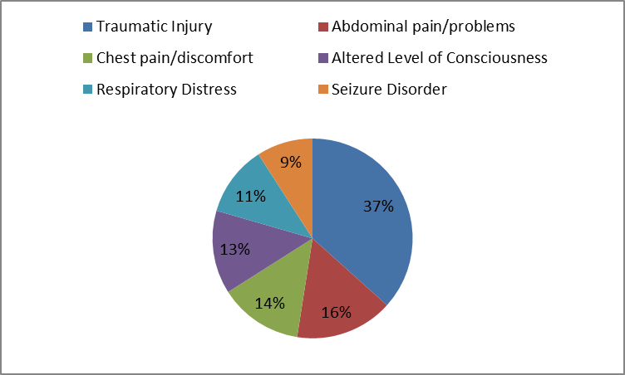

The average cost per incident for In City incidents is $1,943, and currently, the average transport fee and utility rate revenue only support $952 of the cost. This is about a 49% cost recovery per incident.

***EMS Analysis***

* **Low impact/High probability** – if the incident happens, the fire department can usually handle it with existing resources. However, effort should be given to reduce the likelihood that these incidents occur.
* Multi-family residential occupancies represent 2% of the total occupancies within the City, but represent 24% of the EMS call frequency.

***Event Probability of Occurrence***

There are various methods for calculating the probability of occurrence. For the purposes of this document percentage of event types were averaged over a five-year time frame (2011-2015). The event type percentage used to calculate probability of events for this deployment standard is described in the following charts.

Based upon the historical trends presented thus far, it is reasonable to extrapolate that calls for service will continue to trend upwards. We can assume that the event type probability will remain fairly constant, and that based upon historical, geographical and temporal analysis that the calls will continue to occur in the central corridor and northwest portions of the city and be fairly consistent with the activity level of the population. It is also reasonable to project that the primary event categories will be EMS, Service Calls (which include lift assists, burning complaints, etc.), False/Other (which include inadvertent alarm activations, vicinity alarms, etc.) and Fires which can be sub-categorized as structural, wildland, and vehicle.

Calls for service utilize available resources. This resource draw must be considered in the risk analysis. The following chart identifies the average number of responders to the event types.

***Target Hazard Assessment***

Target hazards are locally defined occupancies that pose specific risks to occupants and the fire service responders. Critical infrastructure is a term used by governments to describe assets that are essential for the functioning of a society and economy. The City of Pasco has identified several target hazards and critical infrastructures within its boundaries. The table below identifies the number of facilities that are considered critical to the functioning of the community and/or that present a significant risk to responders or occupants.

|  |  |
| --- | --- |
| **Target Hazard/Critical Infrastructure** | **Number** |
| Governmental Facilities – Includes local, county, federal and Port | 11 |
| Assisted Living Centers/Under Age Day Care | 124 |
| Community Shelter | 2 |
| Schools – includes elementary, secondary, and College | 23 |
| Transportation – Airports, Rail, Barge, Bus | 6 |
| Water/Sewage Treatment Facilities | 4 |
| Communications | 5 |
| Emergency Operations Center | 1 |
| Public Utilities | 2 |
| Hazardous Materials Bulk Storage | 5 |
| Healthcare (Not including Private Practice) | 2 |
| Highrise (75 ft. or greater) | 3 |
| Multi-Family Residential | 430 |

Single family residential units represent the highest percentage of buildings within the City of Pasco (16,715). There are 430 multi-family residences located within the City. The City of Pasco has issued an average of 2600 building permits over the last five years (2011-2016) and most of the building permits have been for single family residential units.

***Community Risk Priorities***

Based on the assessment of incident and demographic data from the last ten years the top three priorities for community risk have been identified. These are potential risks and community impacts that can ultimately be reduced/mitigated through the implementation of various strategies; which will be addressed through a comprehensive community risk reduction plan.

**Risk One – Cooking Fires**

The number one fire risk based on probability and impact to the community, is cooking related fires. Many these calls were confined to the kitchen area. However, in residences without smoke alarms or incidents were the occupant had left the cooking area, there was a much higher magnitude of damage to the occupancy. It should be noted that this confirms the national statistics, in which kitchen fires statistically lead the nation for fire responses.

In Pasco, a disproportionate number of cooking fires happened in multi-family housing as compared to single family residences. Data from the last ten years suggests that thirty percent of fire calls involved multi-family housing, and for forty-five percent of our cooking fires.

**Risk Two- EMS calls for Slip, Trip, and Falls**

The data indicates that several event categories represent a high percentage of the total EMS call volume. However, most of these categories are very broad and generalized for example; sick or breathing problems. It is difficult to develop a plan for reducing these event types. The category of falls can be successfully addressed.

**Risk Three- Ems Category “Not Applicable”**

It may seem odd for a category of Not Applicable to be a risk to a community. However as noted in several places in this report, the number of calls for service are increasing every year and if not addressed, we can expect the percentage of “not applicable” to increase as well.

Without reliable and quantifiable data potential issues are not identified and systemic inefficiencies and effectiveness are not measured. This will result in increased costs and lost opportunities. The importance of insuring quality data cannot be over-emphasized.

***Intervention Strategies***

The Community Risk Reduction (CRR) model categorizes interventions into the 5 “E’s” (Education, Engineering, Enforcement, and Economic Incentives, Emergency Response).

**Education**- Education can influence behavior by increasing awareness, and providing information and knowledge with the intention of producing a desired behavior. Education is only effective if individuals apply this knowledge appropriately. Education needs to be culturally competent for the message to reach its audience.

**Engineering**- Engineering applies to changes in the physical environment. Modifying a product or environment to prevent or mitigate injury, death or destruction of property is an engineering tactic.

**Enforcement**- Enforcement applies to reducing risks through the legislative process of strengthening and/or the adoption of applicable laws. This may include inspection programs or methods, and in some cases, can impose penalties for non-compliance.

**Economic Incentives**- There are two kinds of Economic incentives.

Negative incentives are fines, tickets, or other punishment for “inappropriate behavior” intended to discourage unsafe behaviors.

Positive incentives are rewards or gifts for choosing positive behaviors or choices. Programs like free smoke alarms are examples of positive incentives.

**Emergency Response** – Emergency Response is defined as, having enough manpower and proper equipment to mitigate an emergency when it happens in your community. Statistical evidence suggests that the ratio of responders to the population in Pasco is below the National Standards, thus necessitating the higher priority of prevention.

The following tables address each of the identified risk and the associated intervention based upon the 5 “E’s” described above. Short-term goals are anticipated to be implemented within 12 months, mid-term goals are within 3-5 years and long-term goals are 5-10 years. As with all plans, this document needs to be reviewed periodically to assure relevance and measure the success of the prevention strategies listed.

|  |  |  |  |  |  |
| --- | --- | --- | --- | --- | --- |
| **Risk One-** **Cooking Fires:** Cooking fires are a High impact/High probability risk in our community. | | | | | |
| **Program Goal**: Reduce the number of cooking fires and their effects through education and in home safety assessments, especially in Multi-Family occupancies. | | | | | |
| **Resources Required**: Smoke Alarms, Printed materials, Audio/ Visual equipment  Installation equipment, Training of on duty crews. | | | | | |
| **Premise Statement** | **Projects** | **Short-Term Goals** | | **Intermediate Goals** | **Long-Term Goals** |
| **Education:**  Cooking fires can be minimized or prevented by education. | Develop multi-cultural educational materials and in home safety inspections that reinforce safe cooking practices. | Identify “at risk” populations and occupancies. | | Host activities at public and multi housing events to distribute information, and invitations for home safety surveys. |  |
| **Engineering:**  Smoke Alarms will provide early warning of fire danger, reducing event severity. | Distribute and install fire detection and suppression equipment to at risk populations |  | | Monitor success of smoke alarm program. | Develop building codes requiring residential sprinklers. |
| **Enforcement:**  Collaborate with the Inspection Services to develop and reinforce the safety messages. | Obtain information from the Rental Inspection program to identify occupancies where more education is needed. | Develop in home safety inspection program. | | Perform voluntary in home safety inspections when requested. | Merge fire department and inspection services. |
| **Economic:**  Loss from fire has a negative impact on the General Fund. | Connect people with insurance providers to find the coverage they need. | Identify community partners that will assist in restoration projects. | |  | Achieve a reduction in property loss due to cooking fires. |
| **Emergency Response:**  Early warning of cooking fires will reduce the incident complexity. | Development of a program that identifies at risk occupancies and at risk populations. | Adopt and follow the recommendations of the Pasco Fire Department Master Plan | | Achieve WSRB rating of 4 or better. | . |
| **Rational:** | | | **Assumptions:** | | |
| Cooking fires have a large financial and service impact to the community. | | | The impacts to the community can be reduced through education and early warning and suppression of cooking fires. | | |
| **External expectations:** The reduction of cooking fires will have a positive effect on the achievement of a WSRB Class 4 rating of the community. | | | | | |

|  |  |  |  |  |  |  |  |  |  |  |  |
| --- | --- | --- | --- | --- | --- | --- | --- | --- | --- | --- | --- |
| **Risk Two -** Injuries and deaths from slips, trips and falls. | | | | | | | | | | | |
| **Program Goal**: With collaborative partnerships, provide Safety Education and in-home assessments to prevent future instances. | | | | | | | | | | | |
| **Resources Required**: Safety equipment, Printed materials, Audio/Visual equipment, Installation equipment, and Community Partners. | | | | | | | | | | | |
| **Premise Statement** | | **Projects** | | **Short-Term Goals** | | | | **Intermediate Goals** | | **Long-Term Goals** | |
| **Education**:  “At risk” populations are often unaware of the slip, trip, fall dangers in their homes. | | Utilize local, regional and national resources to develop a slip, trip and fall prevention program. | | Identify “at risk” populations through field data collection and referrals from local service organizations | | | | Develop referral process in order to provide education to “at risk:” populations | |  | |
| **Engineering**:  The probability of slip, trip, falls may be reduced through the use of adjunct equipment. | | Provide voluntary in-home assessments and education for “at risk” populations | |  | | | | Develop collaborative partnerships with local service organizations to provide low cost in home engineering solutions | |  | |
| **Enforcement:**  Emergent care providers do not provide preventative solutions to slip, trip, fall hazards. | | Develop a referral program to provide “follow up” in home assessments for at risk populations. | |  | | | |  | | Reduce the incidents of repeat slip, trip, and fall occurrences. | |
| **Economic**:  Slip, trip and fall hazards can be reduced through education and engineering. | | Provide early in-home assessment and education to reduce strain on EMS system. | | Develop collaborative relationships with area hospitals to provide early in-home assessments and education to at risk populations | | | |  | | Reduce strain on entire EMS system by providing alternative long-term care and monitoring of at risk populations. | |
| **Emergency Response:**  Reduction of slip, trip, fall hazards will provide higher unit availabilities. | | Develop training for recognizing and reporting of at risk populations for slip, trip, and fall hazards. | | Match the incident resource needs to the incident complexity. | | | | Provide comprehensive patient, in-home assessments and follow up to identify early signs of slip, trip and fall hazards. | |  | |
| **Rational:** | | | | | | **Assumptions:** | | | | | |
| Early intervention with “at risk” populations will reduce strain on EMS systems. | | | | | | Slip, Trip and Fall hazards can be reduced through education and engineering solutions. | | | | | |
| **External expectations:** | | | | | | | | | | | |
| Reduction of slip, trip, fall occurrences will decrease strain on the EMS system and provide opportunities for community collaboration programs. | | | | | | | | | | | |
| **Risk Three -** The “Not-Applicable” EMS event type is difficult to quantify. This event type can range from non-emergent, no transport incidents to those incidents that do not “fit” into the identified categories. | | | | | | | | | | |
| **Program Goal:** Correctly identify and categorize EMS events. | | | | | | | | | | |
| **Resources Required:** Focused training of responders and data analysts in order to correctly categorized events. | | | | | | | | | | |
| **Premise Statement** | **Projects** | | **Short-Term Goals** | | | | **Intermediate Goals** | | **Long-Term Goals** | | |
| **Education:**  “Field” data collection is inconsistent and inaccurate. | Provide consistent and regular training to EMS responders in order to correctly categorize emergent event types. | | Regularly audit “not applicable” category. | | | | Evaluate impacts of findings on department programs and finances. | | Reduce inconsistency in reporting. | | |
| **Engineering:**  Without accurate and reliable data, program needs cannot be determined. | Evaluate impacts of findings on department programs | | Determine and develop programs to reduce service impacts and costs | | | |  | |  | | |
| **Enforcement:**  A system needs to be developed to prove the accuracy of field data. | Develop processes and policies in that the “not applicable” category choice triggers automatic QA review. | | Develop policy and procedures that address record accuracy. | | | | Develop procedures within the RMS to automatically queue these event types for further review and categorization | |  | | |
| **Economic:**  Accurate data is foundational to determination of accurate costs. | Correctly categorize “not applicable” events in order to improve financial reimbursement percentages | |  | | | |  | | Improve ability to capture EMS service provision costs and improve financial reimbursement percentages. | | |
| **Emergency Response:**  Event types determine unit utilization. | Determine resource allocation to fit the event needs. | |  | | | |  | | Reduction of over-lapping calls and provide better resource utilization. | | |
| **Rational:** | | | | | **Assumptions:** | | | | | | |
| Unquantifiable data decreases service efficiencies and increases service costs. | | | | | Accurate reporting will identify community needs and increase response effectiveness. | | | | | | |
| **External expectations:** | | | | | | | | | | | |
| Increasing response effectiveness and efficiency will provide for better unit utilization and reduce overall costs and increase reimbursement percentages. | | | | | | | | | | | |

***Works Cited***

*Pasco Fire Department Emergency Services Master Plan – Summer 2016*

*Prepared by: Don Bivins, Jim Mooney, Martin Goughnout, Rob Strong, Stuart McElhaney*

*Emergency Services Consulting International*

*Standards of Cover – February 2017*

*Prepared by: David Hare, Asst. Fire Chief – Pasco Fire Department*

*Franklin County Comprehensive Emergency Management Plan – 2015*

*Prepared by: Franklin County Emergency Management*

*Region 8 Healthcare Systems Preparedness and Response Plan Rev. 10 – June 2013*

*Prepared by: Washington State Department of Health and Washington State Hospital Association.*